Letter of Intent
Phillips 66 Branded Supply Agreement
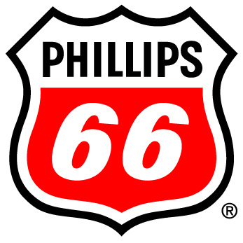

between
Customer Site,
the Dealer
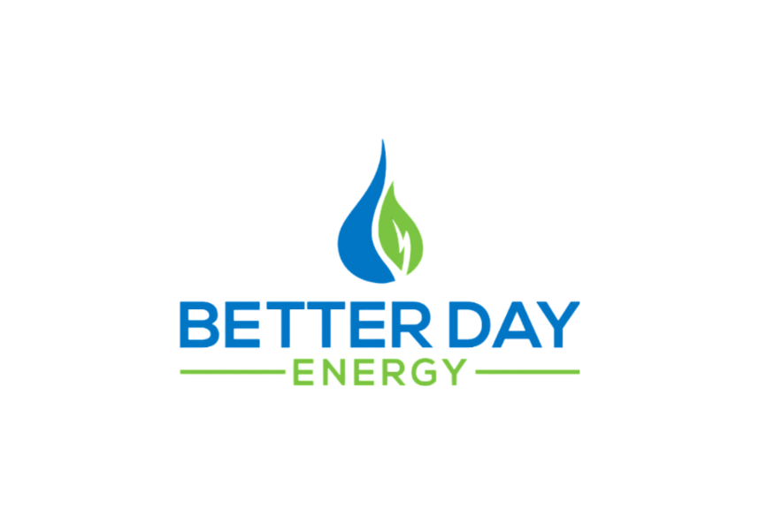
and

the Jobber

Originally Proposed 6-6-2025
Valid until 7-6-2025

Introduction
Better Day Energy is a fuel distributor, (the “Jobber”) based in Hillsboro, MO and doing business in Missouri. _________________ is a fuel dealer operating a retail convenience store located at ___________________________ (the “Dealer”).

Proposal
Better Day Energy proposes to provide brand imaging funds, consulting services, and fuel supply and delivery services in exchange for an exclusive 10-year fuel supply agreement with the Dealer to purchase __________ gallons gasoline and ____________ gallons diesel per month.

Value
Better Day Energy offers a number of programs which create value for our customers including competitive fuel pricing, low credit card transaction fees, world-recognized Phillips 66 Brand image, fuel industry expertise providing on-going support to your station’s operations as increasing and changing Federal, State, and Local regulations impact the way you do business.

Incentives
Image Funding for Phillips 66 Branded fascia, signs, LED halo lighting, main ID sign faces, and digital product pricing board for fuel pricing. Valued $85,000 per site
Incentive Funding based on contract performance. Valued $45,000 for Kincaid
Valued $100,000 for Mt Sterling
Rebate compliant fuel supply and monthly reporting to state and federal fuel programs. Valued $216,000

Project Details and Timeline
Critical to the success of this project and securing the available incentive money to realize the full value of this proposal is adherence to the project timeline and required qualifying activities.
- Execute Fuel Supply Agreement
- Convert Credit Cards and begin B11/E10 fuel supply
- Solicit existing supplier for transfer
- Secure site transfer and/or debrand
- Execute project and imaging contract documents with vendors
- Install Canopy if required.
- Conoco Phillips Imaging Project
  - Image canopy with fascia, signs, and LED halo lighting.
  - Replace main ID sign faces with brand signs.
  - Install new digital product pricing board for gasoline.
- Submit final invoices, proof of payment, and evidence of project completion to brand for project reimbursements

Acceptance of Letter of Intent as proposed:
Dealer, Better Day Energy LLC
By: By:
Name: Name:
Title: Title:
Date: Date:

